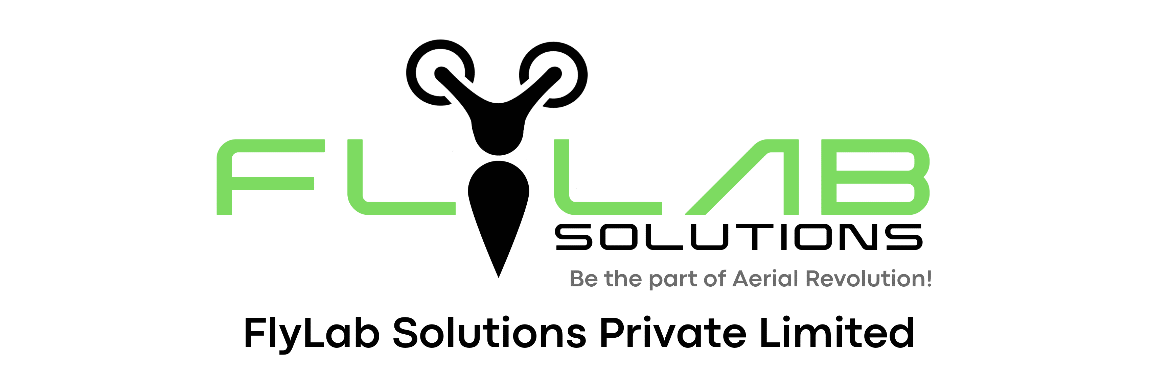

Team Catch-up

1. What inspired you to join this startup, and what keeps you motivated to work without any ask?  
  
2. How can we better support you in your roles within the company?  
  
3. Are there specific skills or resources you feel you need to be more effective in your work?  
  
4. What are your long-term goals with the company, and how can we align our efforts to help you achieve them?  
  
5. Is there anything you find challenging or demotivating about the current situation, and how can we address those challenges?  
  
6. What ideas do you have for growing the startup and enhancing its success?  
  
7. Are there any personal or professional development opportunities you'd like to explore within the company?  
  
8. How can we improve communication and collaboration within the team?  
  
9. What other types of support or recognition would you find meaningful for your hard work and dedication?

10. Do you have any concerns or feedback about the direction or vision of the company that you'd like to discuss?  
  
11. What are the three things that you learnt after joining FlyLab?  
  
12. Draft the names of any 2 people you feel work hard for the company? (One Founder & one teammate)